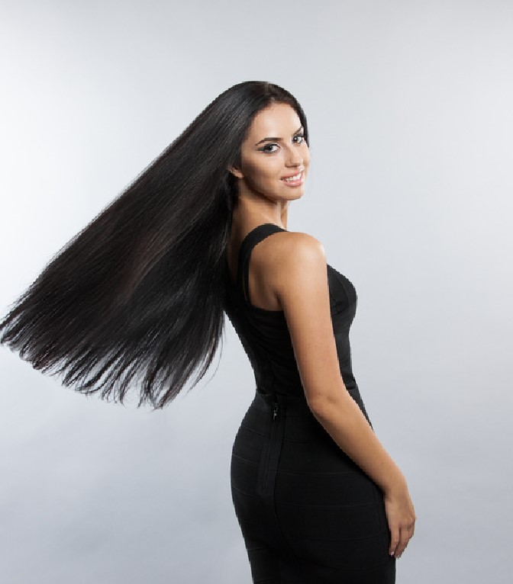

**Anywhere St., Any City**

**123**

**modeloscv.org**

**+123-456-7890**

**EXPERIENCE**

**Traveling**

**Photography**

**Music**

**PERSONAL SKILLS**

**INTEREST**

**MARICEL**

**MERCADO**

**P**

**R**

**O**

**F**

**F**

**E**

**S**

**I**

**O**

**N**

**A**

**L**

**M**

**O**

**D**

**E**

**L**

I am a model with a lot of experience. I

like modeling because I feel like I'm the

main focal point among many people.

I also have many achievements in

modeling such as photo shoots,

commercials, and fashion shows.

**Larana, Inc**

Conducting research on designers

fashionwear as well as other products

that are to be modeled and promoted.

Following the directions of

photographers and posing for

photoshoots accordingly.

**Fradel and Spies Collection**

Participating in runway shows by

modeling designers’ clothing,

accessories, footwear, and jewelry.

**Borcelle fitness**

Following suitable health and fitness

regimens to maintain a well-defined

physical appearance in accordance

with industry standards.

Time

management

Public

Speaking

Dexterity

Leadership

Communication

Self control